CST 320 – Assignment 3 part 1
Wilsonville, Fall 2017

Note: In this assignment, non-terminals are upper case and terminals are lower case.

- Given the grammar G =
A → bgB | dA | g
B → Ca | gA
C → aC | bdA | b
Determine and indicate which of the following strings are in the language defined by G and which are not. Construct parse trees for those that are in the language.

bgg
ddbggg
bgaba
bggdg
dad
bgba
abd
dbga

“bgg”
A
bgB
Not in the language!
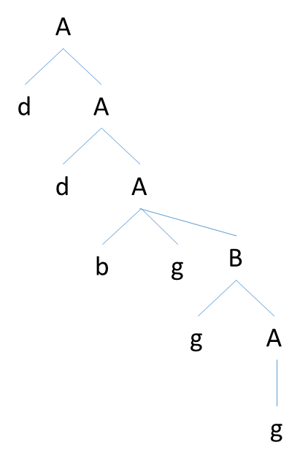
“ddbggg”
A
dA
ddA
ddbgB
ddbggA
ddbggg

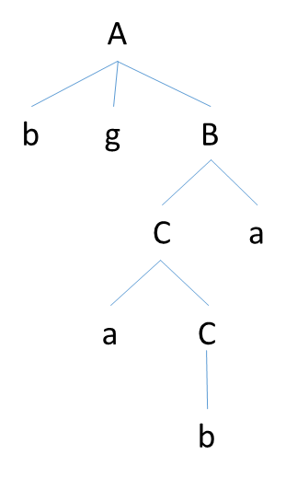
“bgaba”
A
bgB
bgCa
bgaCa
bgaba

“bggdg”
A
bgB
bggA
bggdA
bggdg
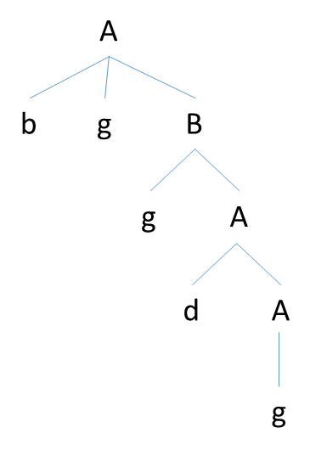

“dad”
A
dA
dbgB or dg or ddA
Not in Language!

“bgba”
A
bgB
bgCa
bgba

“abd”
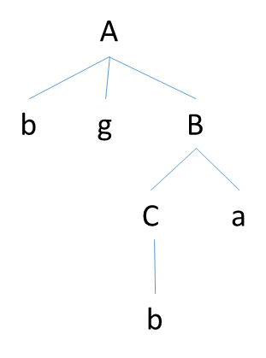
A
bgB or dA or g
Not in Language!

“dbga”
A
dA
dbgB
dbgCa
dbgaCa or dbgagAa
Not in Language!

- Given the following grammar
S → aSbS | bSaS | λ
Show that this grammar is ambiguous by constructing two different left-most derivations for the sentence “abab”.

S
aSbS
aλbS
aλbaSbS
aλbaλbS
aλbaλbλ
abab

S
aSbS
abSaSbS
abλaSbS
abλaλbS
abλaλbλ
abab

- Using the following grammar:
E → E + T | E – T | T
T → T * F | T / F | F
F → ( E ) | i
Construct parse trees and left-most derivations for the following expressions:
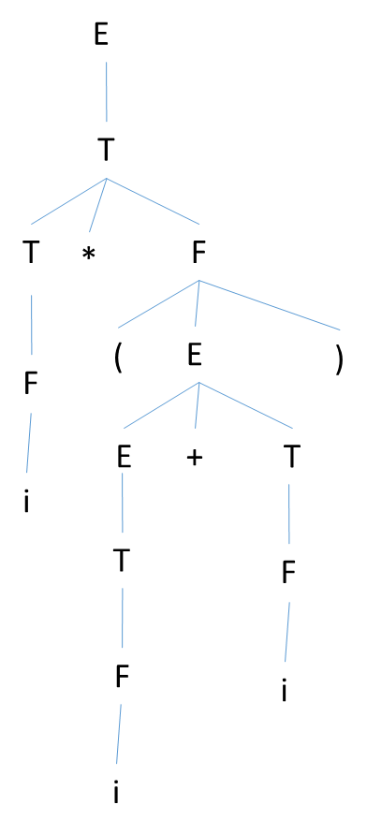
- i * (i + i)

E
T
T*F
F*F
i*F
i*(E)
i*(E+T)
i*(T+T)
i*(F+T)
i*(i+T)
i*(i+F)
i * (i + i)

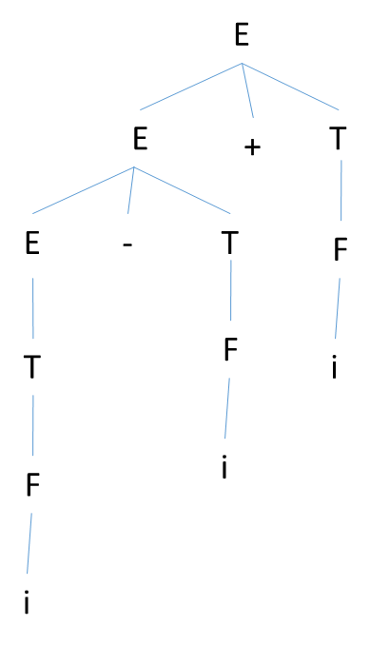
- i – i + i
E
E+T
E-T+T
T-T+T
F-T+T
i-T+T
i-F+T
i-i+T
i-i+F
i – i + i

